Acceptable Methods of Window and Door Flashing
Protecting openings in a building’s envelope is paramount to the structural integrity of a building. However, water ingress can also hinder the energy performance of a house (dampening insulation, as an example), and create obvious health concerns related to mold growth. For these reasons, among others, properly flashing your windows and doors during installation is essential to the longevity and safety of a building and its occupants. Here are some of the flashing methods currently accepted by the Building Inspection department at the Capital Region Service Commission:
- The Bitumous/Flashing Tape Method:

The Capital Region Service Commission recognizes that the majority of window installations are as per direction of window manufacturers’ instructions and industry best practices. The following is an acceptable installation method within CRSC’s jurisdiction:

- Cut the sheathing barrier around the window’s rough size opening (RSO), fold the top of the sheathing membrane to reveal the sheathing, and install a flashing membrane to the sill of the RSO as illustrated:

- Run a bead of silicone around the exterior sides and top of the RSO and install the window in the RSO as per manufacturer's instructions regarding shimming:

- Install bitumous/flashing tape on the sides of the window overtop of the nailing flange and extending above the window in such a way that the flashing tape overtop the window will be over the sides as illustrated:

- Install flashing tape overtop of the window, ensuring it overlaps the vertical flashing on the sides of the window:

- Fold the sheathing barrier down overtop of the flashing tape and tape the sheathing barrier to the flashing tape using Tuck Tape or a similar product:

- The Prescriptive National Building Code Method:

The National Building Code has a detailed flashing method that can be found in Section 9.27. The Code directs users to Articles 9.27.3.7 and 9.276.3.8., which are outlined below:
First off is the flashing material. It can be one of the following:
- 1.73 mm thick sheet lead
- .33 mm thick galvanized steel
- .46 mm thick copper
- .46 mm thick zinc
- .48 mm thick aluminum, or
- 1.02 mm thick vinyl
Once you’ve chosen one of the materials listed above, it’s imperative that it is installed correctly. The installation method can be found in Sentence 9.27.3.8.(4) and is summarized here:
- The flashing overtop of the window door shall extend up the sheathing 50 mm, or 2”. The flashing is required to go under the sheathing barrier, and if a sheathing barrier is not required (such as in a garage as constructed as per Section 9.35), the flashing shall be installed behind whatever is being used to sheath the building.

- The flashing is to have a slope of 6º toward the exterior of the building, and at each of the opening, the flashing shall have an end dam, which is described as follows:
  - Each end dam must have a height of 25 mm/1” and extend to the face of the adjacent cladding.

- Lastly, the flashing must extend outwards for a 5 mm or 3/16” offset from the window/door.

Here is a diagram of the method above, sourced from the Notes to Part 9 in the NBC:
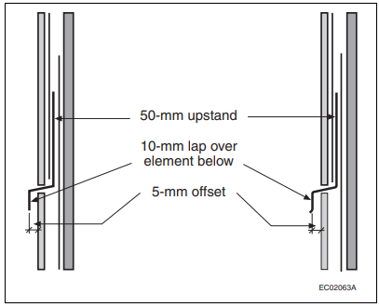

- If the bottom of a window/door is not self-flashing—which they typically are not—a flashing is to be installed at the bottom of the window as well, which includes the same 6º slope to the exterior of the building.

- Of course, sealants such as silicone are required to be applied between every window/door and the siding, masonry, or stucco of a building as well.

